**Smart Weather Project with Jira**

**Project Name: Aidens Smart Weather Report with Jira**

**Project Owner:** Anish Issac

Created Jira account and created project: yes, ASWRWJ

**Created 5 Epics and User Stories**

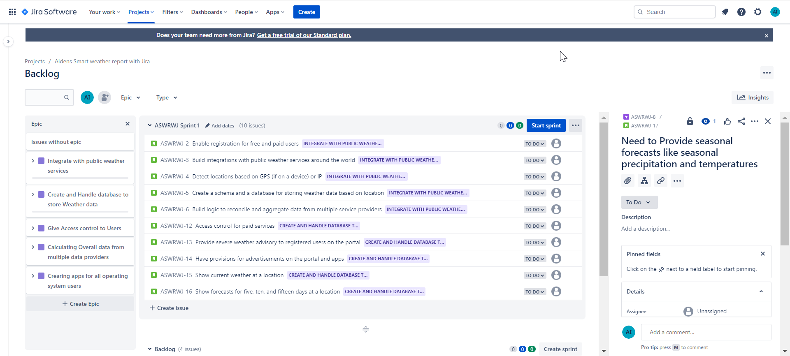

**Tentative release plan: Backlog entered with Epic stories and sprints. Also assigning user stories to three sprints**

**Created Sprint 1 with 10 user stories**

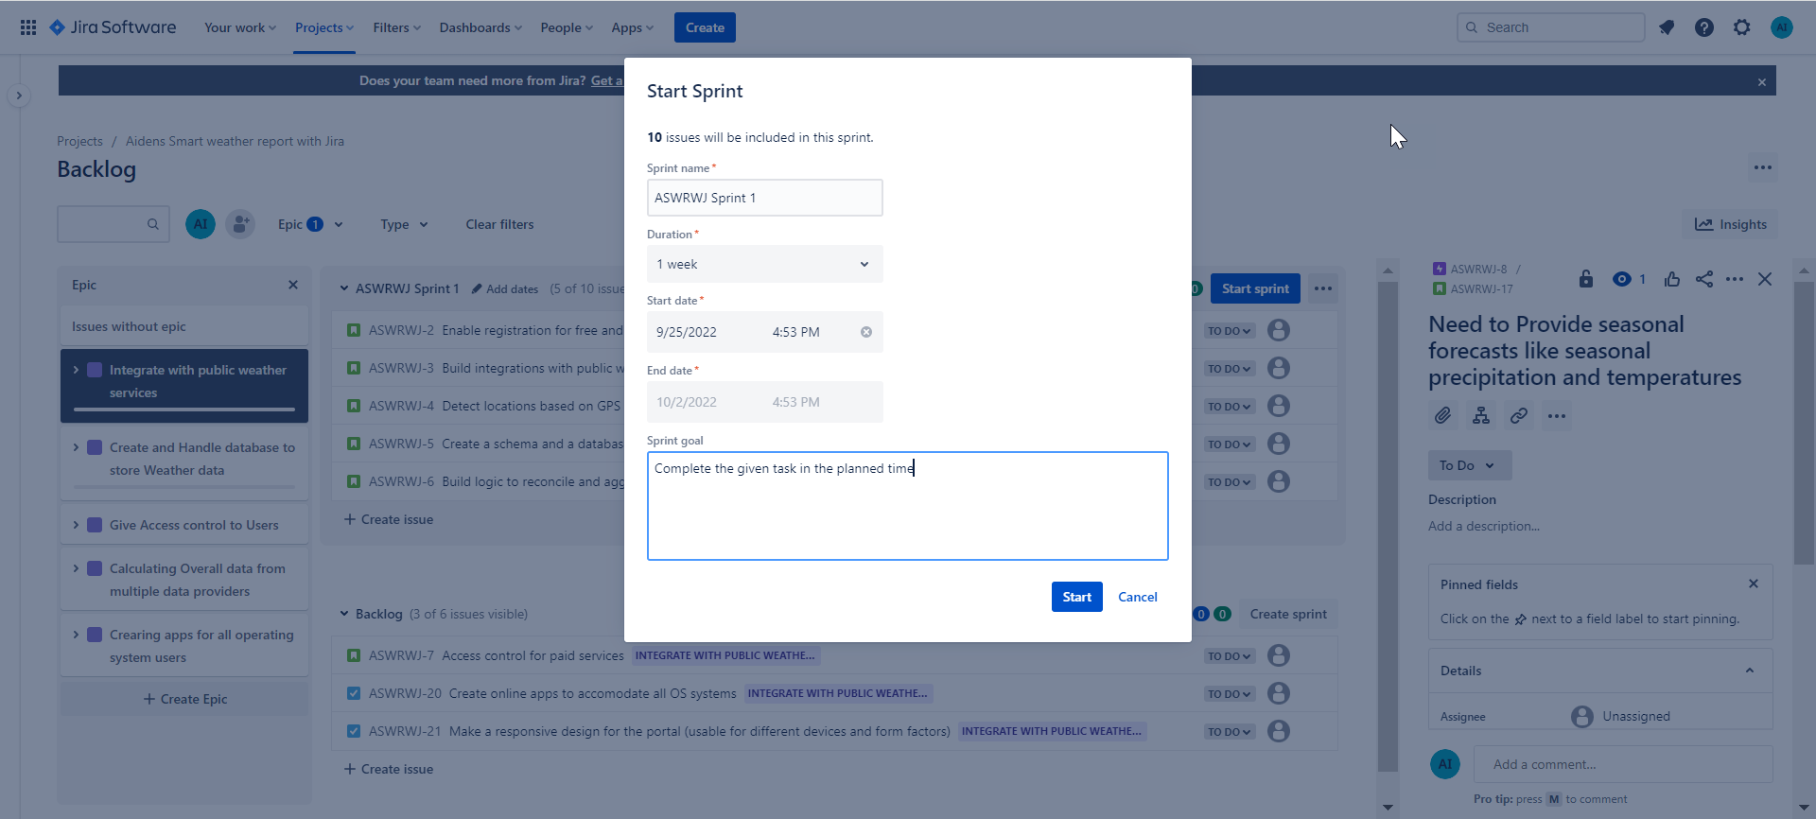

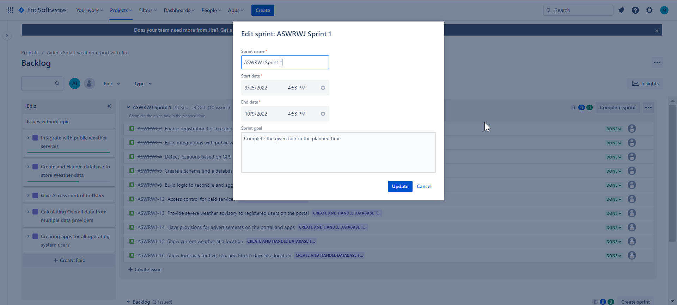

**Completed Sprint 1 successfully. Story Status is complete for all.**

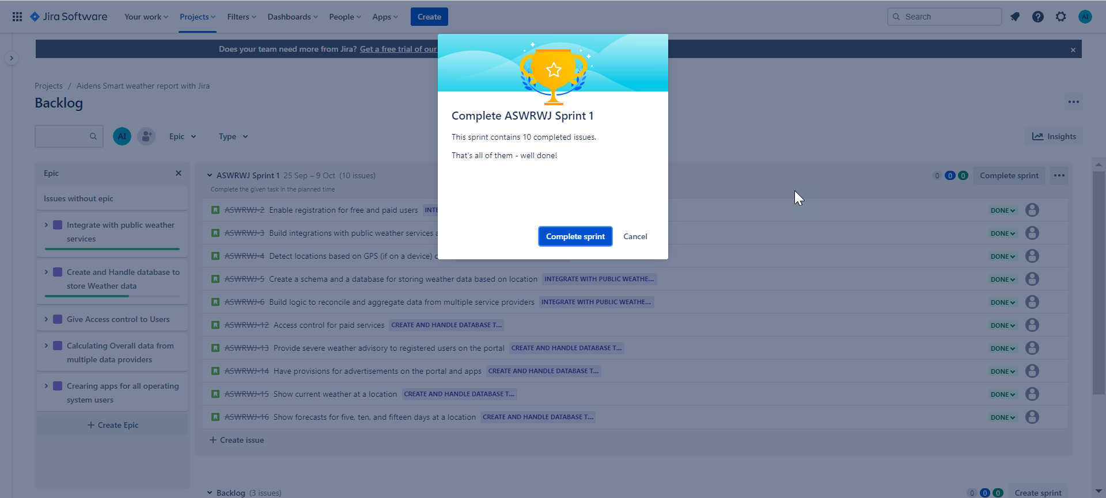

**Sprint Status for Sprint 1 is: Complete**

**Created Sprint 2: Showing different status of User stories - in ‘Progress’, To Do and ‘Complete’**

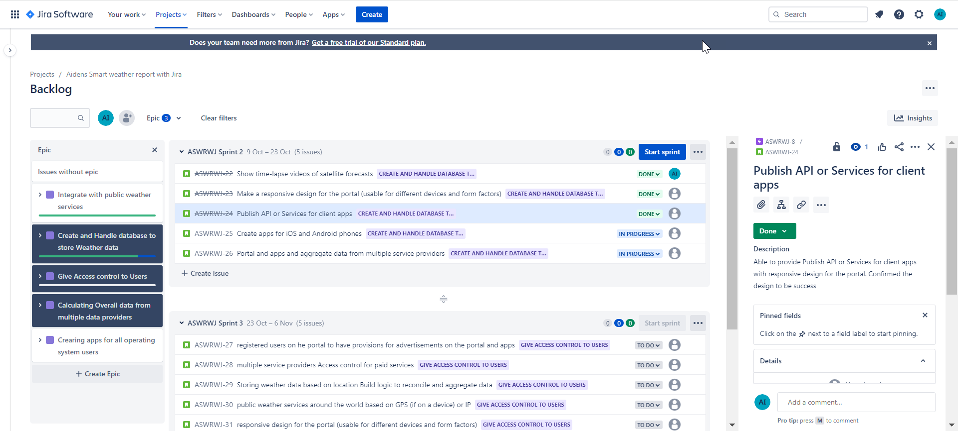

**Created Sprint 3: Scrum Board with User Stories, showing sub tasks, story points, status of stories**

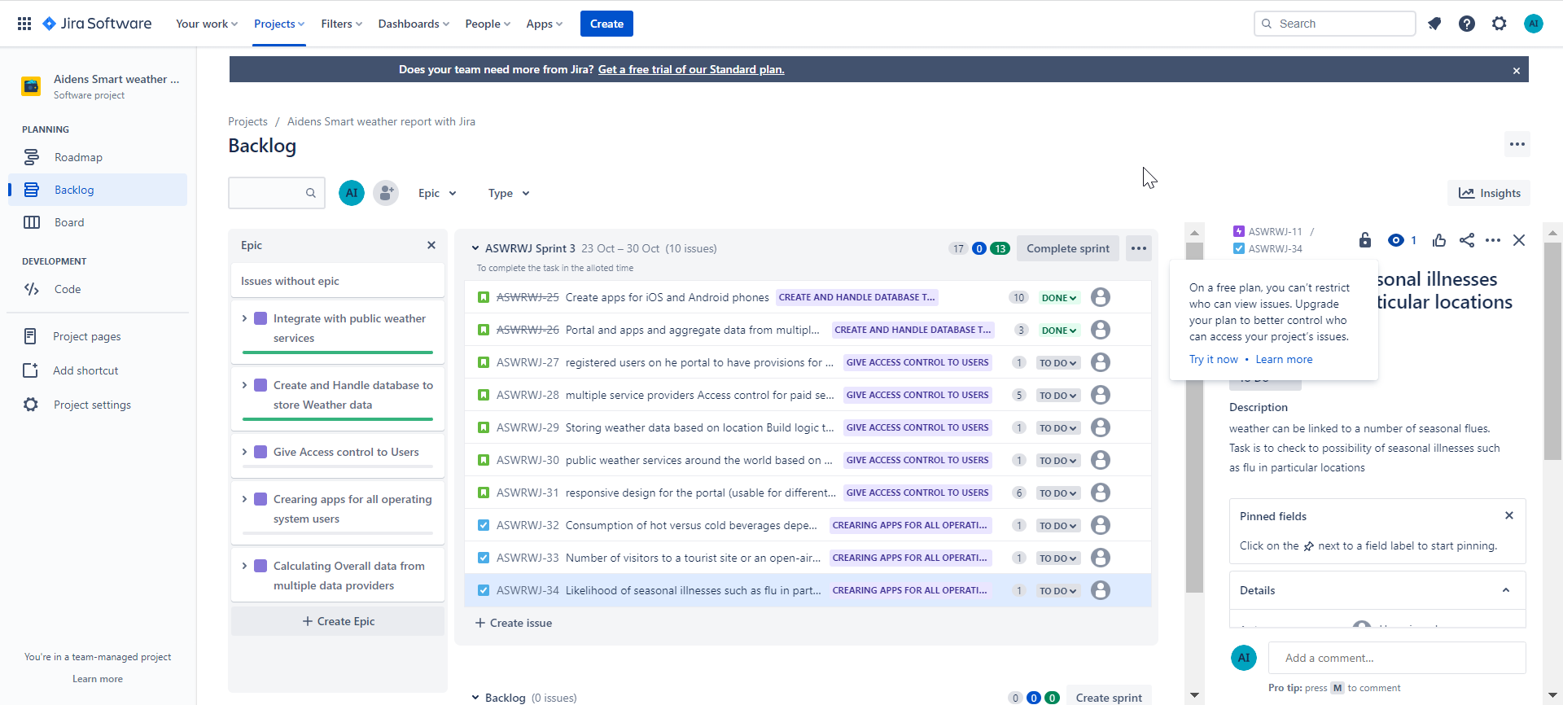

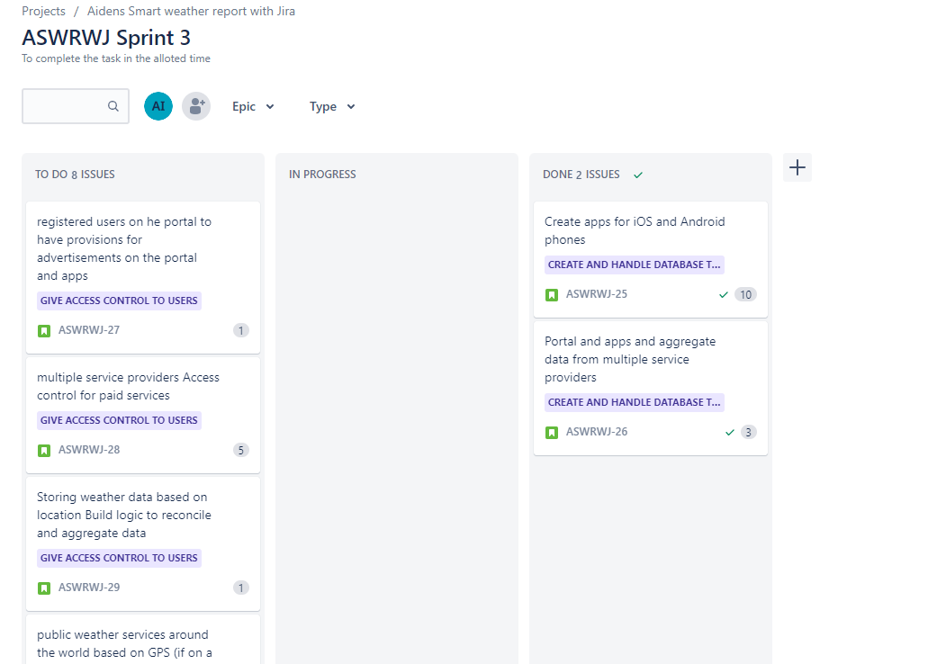

**Issues**

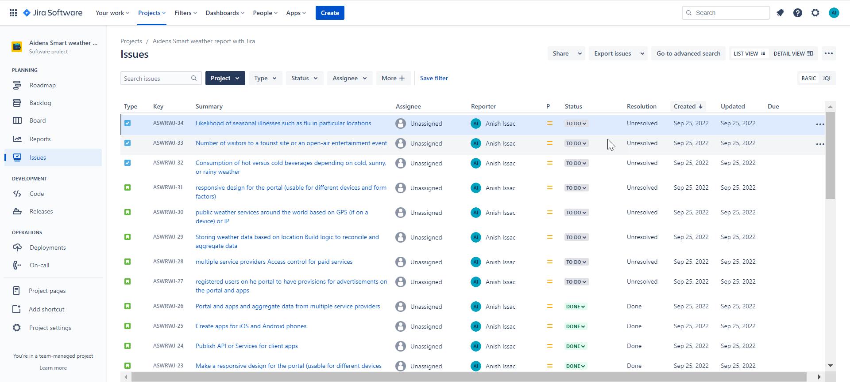

**Screenshot of Release plan**

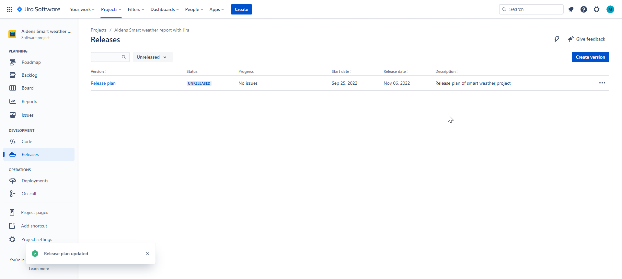

**Completed project for SimpliLearn**